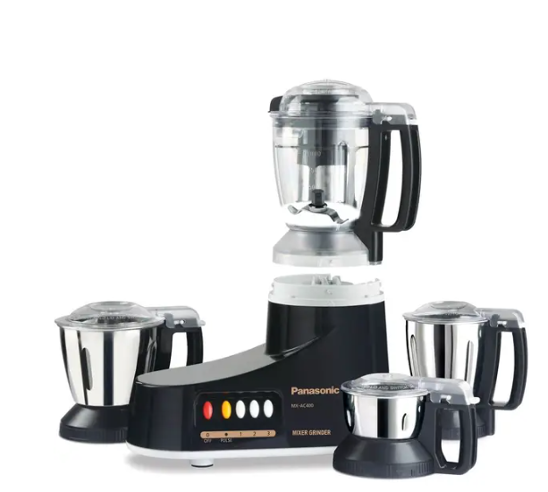
Panasonic Mixer Grinder
Rs.27,000
A Panasonic mixer grinder is a multi-purpose kitchen appliance used for grinding spices, blending liquids, and preparing pastes or batters efficiently. It is designed for daily cooking tasks with powerful performance and safety features.

Specifications
- Power: ~340W – 1000W (varies by model)
- Speed Settings: 3 speeds + pulse
- Dimensions: Approx. 430 × 340 × 170 mm
- Voltage: 220–240V

Key Features
- Multipurpose Functionality
- Hardened Stainless Steel Blades
- Auto open drying
- Adjustable Temperature Control
- Safety Lock System

